6. Sampling Distribution

Definition 6.1
A parameter is a numerical descriptive measure of a population. Because it is based on the observations in the population, its value is almost always unknown.
Definition 6.2
A sample statistic is a numerical descriptive measure of a sample. It is calculated from the observation in the sample.

6.1 What is a Sampling Distribution?
Definition 6.3
The sampling distribution of a sample statistic calculated from a sample of n measurements is the probability distribution of the statistic.
A statistic is generally used to estimate a population parameter which is a fixed but unknown number that describe the population.
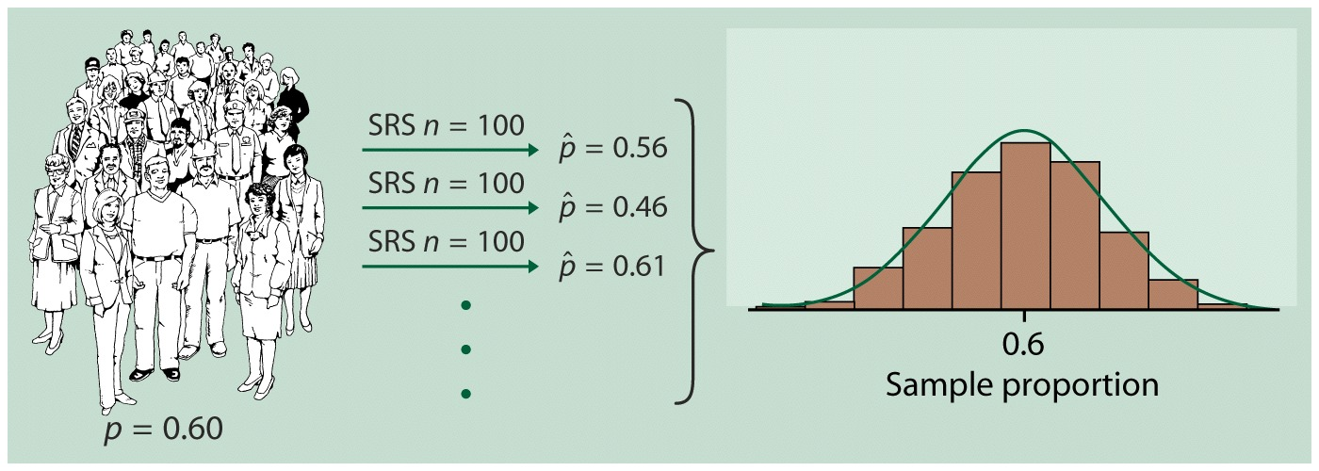
Figure The results of many SRSs have a regular pattern. Here, we draw 1000 SRSs of size 100 from the same population. The population proportion is 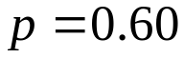. The histogram shows the distribution of the 1000 sample proportions 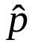.
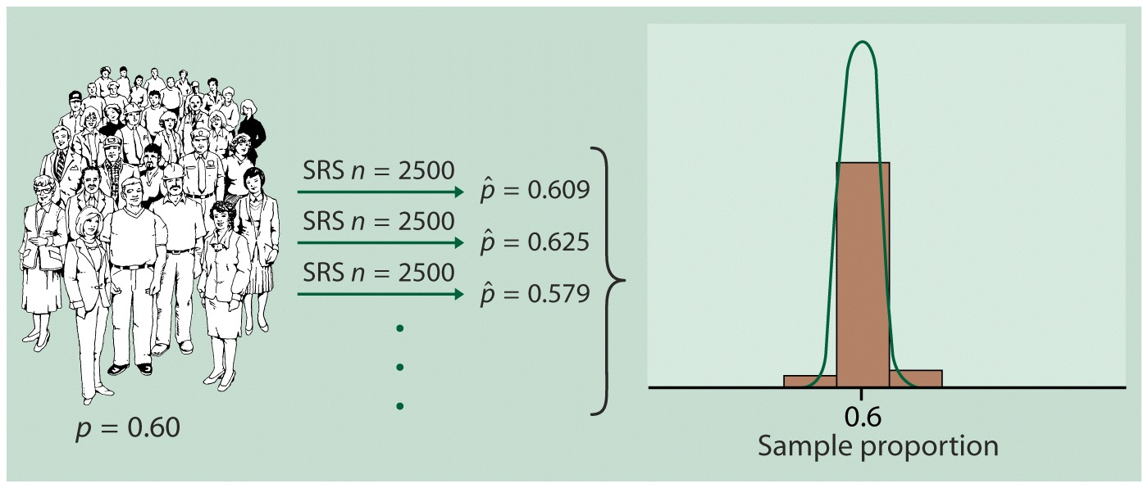
Figure The distribution of sample proportions for 1000 SRSs of size 2500 drawn from the same proportion as in Figure 3.6. The two histograms have the same scale. The statistic from the larger sample is less variable.
Let’s look at Example 6.1 in our textbook (page 294).

6.2 Properties of Sampling Distributions: Unbiasedness and Minimum Variance
Definition 6.4
A point estimator of a population parameter is a rule or formula that tells us how to use the sample data to calculate a single number that can be used as an estimate of the population parameter.
For example, the sample mean 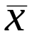 is a point estimator of the population mean 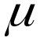. Similarly, the sample variance 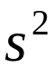 is a point estimator of the population variance 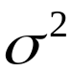.

Let’s look at Example 6.3 in our textbook (page 299).

Definition 6.5
If the sampling distribution of a sample statistic has a mean equal to the population parameter the statistic is intended to estimate, the statistic is said to be an unbiased estimate of the parameter.
If the mean of the sampling distribution is not equal to the parameter, the statistic is said to be a biased estimate of the parameter.
A point estimator of a population parameter is a rule or formula that tells us how to use the sample data

Let’s look at Example 6.4 in our textbook (page 300).

6.3 The Central Limit Theorem
Properties of the Sampling Distribution of
Mean of sampling distribution equals mean of sampled population. That is,
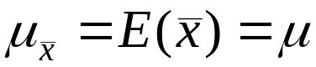.
Standard deviation of sampling distribution equals
Standard deviation of sampled population/ Square root of sample size
That is,
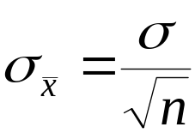.
The standard deviation 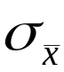 is often referred to as the standard error of the mean.

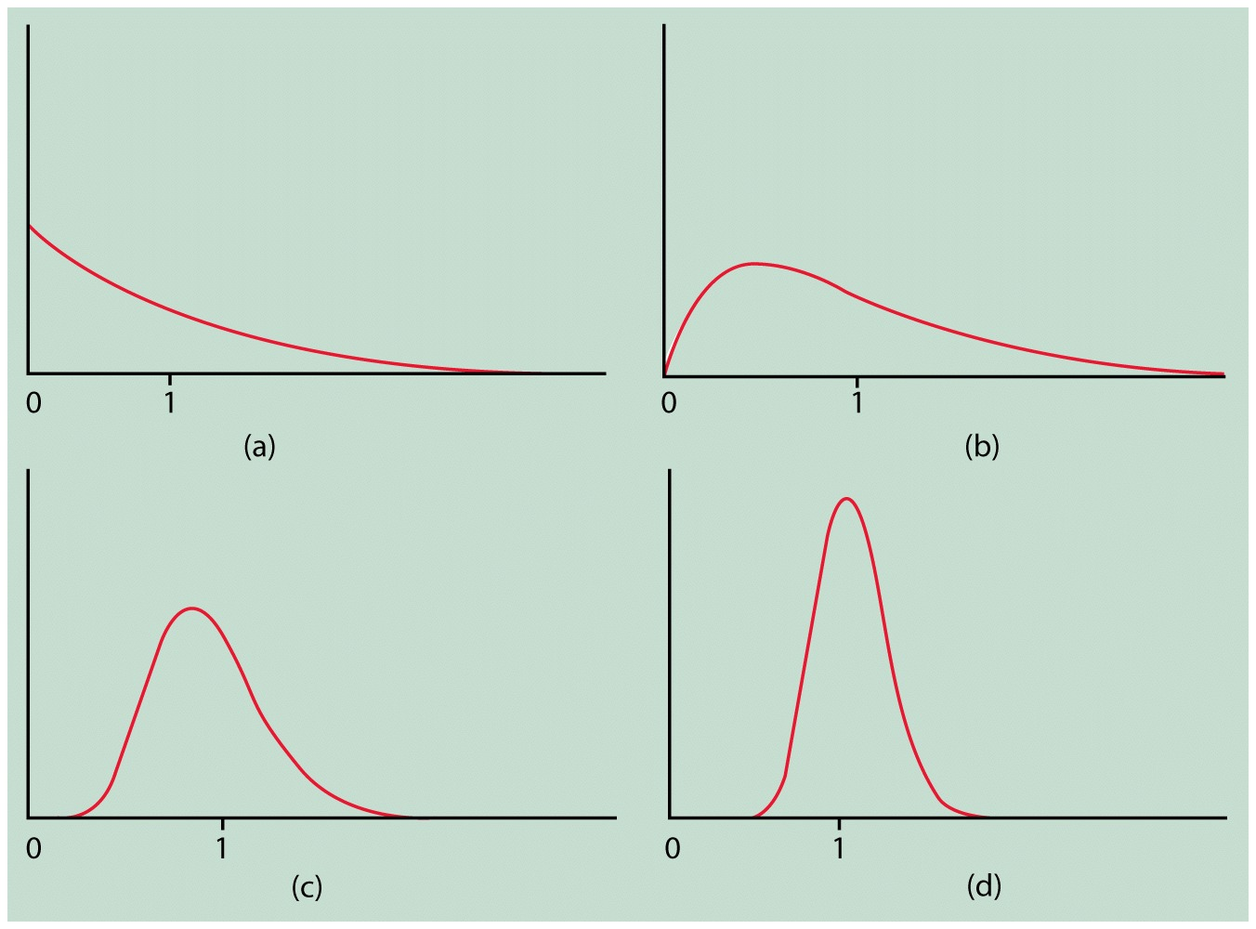

Figure The central limit theorem in action: the distribution of a sample means from a strongly nonnormal population becomes more normal as the sample size increases. (a) The distribution of 1 observation. (b) the distribution of 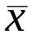 for 2 observations. (c) the distribution of for 10 observations. (d) the distribution of for 25 observations.

Central Limit Theorem

Consider a random sample of n observations selected from a population (any population) with mean and standard deviation 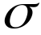. Then, when n is sufficiently large, the sampling distribution of will be approximately a normal distribution with mean 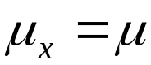 and standard deviation . The larger the sample size, the better will be the normal approximation to the sampling distribution of .
Let’s look at Examples 6.7 through 6.8 in our textbook (page 305).

